**INTRODUCTION**

**1.1 OVERVIEW OF THE PROJECT**

In our day to day lives we can see a person standing in front of our house from electricity board, whose duty is to read the energy meter and handover the bills to the owner of that house every two months once. This is a very tedious task and the accuracy provided is also very low. Many times common errors like extra bill amount ornotification from electric board are sent to the user even though the bills are paid. Currently several applications are being created to sort out this issue, but in vain.To overcome all these drawbacks we have come up with a comprehensive plan and idea which will eliminate the third party between the consumer and service provider and all the common errors will be eliminated.

**1.2 EXISTING SYSTEM**

In the existing system a person from the EB office visits each house two months once, whose duty is to read the energy meter and handover the bills to the owner of that house every two months once. This is nothing but meter reading. According to that reading the user has to pay the bills. The main drawback of this system is that person has to go area by area and has to read the meter of every house and handover the bills. All the readings will be updated in the database once the person completes visiting all the houses in the areas allocated to him, which may take 2-3 days. Many times errors like extra bill amount ornotification from electric board is sent to the user even though the bills are paid occur. The major drawback is that whenever the customer is not present in the house while the reading is taken the user has to note down the readings and pay to the EB office or he has to pay the previous months usage, which is a loss to the user if he/she has consumed less power compared to the previous month.When the voltage goes low all the home appliances in order to work efficiently start consuming more power, which the consumers are not aware off.

**1.3 NEED FOR PROPOSED SYSTEM**

In modern days customer interests focuses more on using the current technologies available. Nowadays the world is moving towards a smart system where IoT is used in all walks of life. Hence we have introduced a‘IoT Based Smart Energy Meter.’

The proposed model is used to calculate the energy consumption of the household, and even make the energy unit reading to be handy. Low voltage intimation is also sent to the use. Hence it reduces the wastage of energy and brings awareness among all the consumers. Even it deducts the manual intervention.

**1.4 DESCRIPTION OF THE PROJECT**

The project mainly deals with smart energy meter, which utilizes the features of embedded systems i.e. combination of hardware and software in order to implement desired functionality.

The project discusses the use of PIC Microcontroller and the application of GSM to introduce ‘Smart’ concept. This system enables the electricity department to read the meter readings monthly without a person visiting each house. This can be achieved by the use of PIC microcontroller that continuously monitor and records the energy meter reading .This system continuously records the reading and the live meter reading can be displayed on the mobile application to the consumer with the help of GSM.

Another major module of the application is that it allows the consumers to receive a notification in the form of SMS through GSM when the voltage value goes below the threshold value that has been set. When the consumer receives the low voltage intimation he is requested to select two devices from the mobile application which they do not require which can be switched off so as to prevent the devices from consuming more power.

The last phase of the project is online payment of electricity bill. Waiting in queues for payment is a tough task in this therefore we have implemented a secure payment portal by which once when the user receives the bill payment can be made.

This system enables the electricity department to read the meter readings monthly without a person visiting each house. An attempt has been made to make a practical model of ‘IoT Based Smart Energy Meter.’

**LITERATURE SURVEY**

**2.1 INTRODUCTION**

A literature survey is an objective, critical summary of published research literature relevant to a topic under consideration for research. Its purpose is to create familiarity with current thinking and research on a particular topic, and may justify future research into a previously overlooked or understudied area. It is the most important part of the report as it gives a direction in the area of research. It helps to set a goal for the analysis thus giving out problem statement. A literature review in respect of the project, the researches made by various analysts – their methodology (which is basically their abstract) and the conclusion they have arrived at. It also gives an account of how this research has influenced the thesis.

**2.1.1 PURPOSE OF LITERATURE SURVEY**

* Identifies gaps in current knowledge.
* Helps to avoid reinventing the wheel by discovering the research already conducted on a topic.
* Sets the background on what has been explored on a topic so far.
* Increases the breadth of the knowledge in area of research

**2.2 RELATED WORKS**

**2.2.1. REAL TIME ENERGY MEASUREMENT USING SMART METER (2016)**

**Authors :**Jayant.P.Pawar, Amirthaganesh.S, ArunKumar.S and SatieshKumar.B.

This system is concerned about measuring power using hall current sensor and intimate users regarding their power consumption. The data is transmitted in a wireless network and stored in a centralised server. ESP 8266interfaced with Arduino Uno transmits the sensor data to Arduino Yun where it is pre-programmed to send an alert to the users at regular intervals. Intimation to the users also include due date to pay the bill. If the user fails to pay within the stipulated time, the electricity connection will be interrupted. The whole system works in IoT platform which allows remote access of the device and the data is stored in cloud. Only data of authenticated users will be stored. Credentials are provided to individual users which allow themto regularly check their power consumption**.**

**2.2.2. SMART ELECTRICITY METER DATA INTELLIGENCE FOR FUTURE ENERGY SYSTEMS: A SURVEY(2016)**

**Authors**: DammindaAlahakoon and Xinghuo Yu

Smart meters have been deployed in many countries across the world since early 2000s. The smart meter as a key element for the smart grid is expected to provide economic, social, and environmental benefit for multiple stakeholders. There has been much debate over the real values of smart meters. One of the key factors that will determine the success of smart meters is smart meter data analytics, which deals with data acquisition, transmission, processing, and interpretation that bring benefits to all stakeholders. This paper presents a comprehensive survey of smart electricity meters and their utilization focusing on key aspects of the metering process, different stakeholder interests, and the technologies used to satisfy stakeholder interests. Furthermore, the paper highlights challenges as well as opportunities arising due to the advent of big data and the increasing popularity of cloud environments.

**2.2.3 .SMART METERING PLATFORM AS A SOLUTION FOR DATA ANALYSIS**

**Authors:**NegreaLiviuAndrei,VladimirTanasiev, MihaiSanduleac and Adrian Badea.

Smart metering is one of the main objectives for the EU member states to ensure the benefit of consumers on the long term. Due to its functionality, smart meters have a wide applicability in: power quality monitoring, energy savings, data awareness and fraud detection. With long-term cost benefits of the smart meters, it is expected that 72% of European consumers will have a smart meter for electricity and 40% for gas by the year 2020. The successful roll-out is depended on each state regulation, interoperability, security and data privacy. In this paper, we reveal the potential of an open source smart metering solution based on an SMX (Smart Meter eXtention) platform, as a low-cost solution for data storage, processing anddata analysis.

**2.2.4.SMART METER PRIVACY WITH RENEWABLE ENERGY AND AN ENERGY STORAGE DEVICE(2017)**

**Authors:**GiulioGiaconi, DenizG¨und¨uz, and H. Vincent Poor.

A smart meter (SM) measures a consumer’s electricity consumption and reports it automatically to a utility provider (UP) in almost real time. Despite many advantages of SMs, their use also leads to serious concerns about consumer privacy. In this paper, SM privacy is studied by considering the presence of a renewable energy source (RES) and a rechargeable battery (RB), which can be used to partially hide the consumer’s energyconsumption behaviour. Privacy is measured by the information leakage rate, which denotes the average mutual information between the user’s real energy consumption and the energy requested from the grid, which the SM reads and reports to the UP. The impact of the knowledge of the amount of energy generated by the RES at the UP is also considered. The minimum information leakage rate is characterized as a computable information theoretic single-letter expression in the two extreme cases, that is, when the battery capacity is infinite or zero. Numerical results are presented for the finite battery capacity case to illustrate the potential privacy gains from the existence of an RB. It is shown that, while the information leakage rate decreases with increasing availability of an RES, larger storage capacity is needed to fully exploit the available energy to improve the privacy.

**2.2.5. DATA ANALYSIS OF THE SMART METERS AND ITS APPLICATIONS IN TATUNG UNIVERSITY(2017)**

**Authors:** Wen-Shyong Yu and Yi-Jie Fan

The management of big data for business analytics is one of the important technologies in the world, especiallydata from smart meters giving equipment and devices power usages in industries and in homes to give saving energy, and reducing environmental pollution and flourish. Therefore, the infrastructure of two-way communication of the smart grid plays an important role to monitor real-time power usages in the power system. In this paper, data analysis of the smart meters using power usages fuzzy system in the demonstrativefield of Tatung University is proposed. The meters read the load information corresponding to the equipment or devices, and then send the information to collectors through the wireless ZigBee and wired G3PLC. The collectors transfer data to the Meters Data Management System (MDMS), and then, MDMS sends data as XML files to the server by Internet for analysis. PHP embedded into Joomla links the database and display of theserver dynamically, and resolves the XML file for catching data including CustomerID, MeterID, RecordDate, KW, KVAR, power factor (PF), and Status. Combining CSS and Google Chart API can support enhancement in reading meters by different data reading types and charts in power usages variation real-time, and by comparing the values displayed on the screen and the actual meters.

**2.2.6. SMART ELECTRICITY METER DATA ANALYTICS: A BRIEF REVIEW**

**Authors:**SavitaPawar and Dr. B. F. Momin

The use of smart meters have been increased in many countries across the globe. Smart meters are not only used for measurement of electricity consumption but also used for the measurement of gas and water consumption. The smart meter is an integral part of the smart grid system and its use incurs benefits to people in various aspects such as social, economic and environmental. The smart meters' main functionality is measuring, capturing and transforming data related to usage or consumption of electricity, gas or water and events such as meter status and power quality. Such functionality encounters many data related issues such as the volume of data, the speed of collecting data and complexity. To gain the hidden insights and knowledge from such data we require the advanced data analytical tools and technologies. This paper provides a brief review of tools and technologies used in smart electricity meter data analytics as well as a comprehensive survey of several key analytical applications and techniques and tools used in those applications.

**2.3 FEASIBILITY STUDY:**

The feasibility study is a formal proposal for a new system .Before the project is to begin the project is studied to determine what exactly the user wants depending upon the result of initial investigation. The common factors of feasibility involves

* Technical
* Economical
* Operational

**2.3.1 Technical feasibility:**

Mobile technology is the latest technology in the 21st century. Increasing mobile technology use has changed how the modern family interacts with one another through technology. The number of people using mobile application keeps increasing each day. The main feature of mobile devices is that it enables the user to use a variety of communication technologies such as Wi-Fi, Bluetooth and many more. The growth in this technology makes people live in digital lifestyle.

In this project we have used android studio for developing the mobile application and the coding used is java which is easily understandable and can be used to make any modifications in the future.

**2.3.2 Economical feasibility:**

Energy shortage has become a global challenge. As the country economy is mostly dependent electrical energy, each and every nation is trying to recover their energy crisis.

Smart Grid is efficient energy system with reliability, flexibility, centralized and distributed power generation with fully automated power network .In recent days, most of natural resources are running out of phase. So, an energy efficient system is a global need to increase the utilization of generated power. Smart Meters can ensure such an efficient system.

The intelligent electronic device Smart meters serve as a sensor network to achieve information exchange between load-side and network. It is a computerized replacement of the electrical meter attached to the outer walls of many of our homes today. Smart meters can track usage as a function of time of day, disconnect a customer via software, or send out alarms in case of problems.

The total cost of our project is approximately 5000 which is economically feasible by all walks of people.

**2.3.4 Operational feasibility:**

Operational feasibility is the measure of how well a proposed system solves the problem, and takes the advantage of the opportunities identified during scope definition and how it satisfies the requirements identified in the requirements analysis phase of system development.

To ensure success, desired operational outcomes must be imparted during design and development. These include such design-dependent parameters as reliability, maintainability, supportability, usability, product ability, disposability, sustainability, affordability and others.

If incorrect inputs are given to the mobile application it does not affect the performance of the system. The system performs well under all circumstances.

**3. SYSTEM DESIGN**

**3.1 PROPOSED SYSTEM ARCHITECTURE DESIGN:**

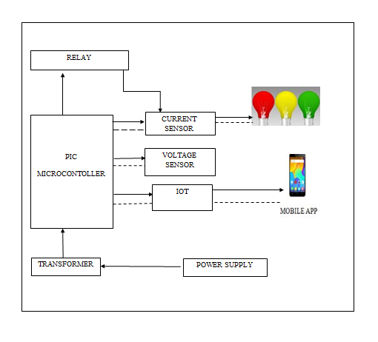

**Fig 3.1 Block diagram of proposed system**

**3.2 DATA FLOW DIAGRAM FOR PROPOSED SYSTEM**

**3.2.1 REGISTRATION AND LOGIN**

This module is that which allows the user to register them with an account so that they get optimal use of the mobile application. The registration module includes getting all account related information which is used to store their data and utilize it whenever necessary. First the user is prompted to enter the information such as first name, last name, consumer number and password. The user has to enter the password again in order to confirm the password. The user is then prompted to enter some additional details such as address, mail id and contact number. Once the user is done with the registration process they must click on the REGISTER button. Now in order to login to their account they must enter their consumer number and password which they chose during the registration process. Therefore the login activity is triggered and the authentication is determined which if true moves on to the main activity else the user is prompted to enter the login details correctly.



**Fig 3.2 Schematic diagram of registration and login module**

**3.2.2 DAILY METER READINGS**

After logging into the system the user is navigated to the next page of the mobile application where the user can monitor the units consumed each day, the units consumed in a week as well as the units consumed each month which helps the user to use electricity in a more efficient manner.

From the power supply 230V is transmitted to the step down transformer which converts the 230V into 12V.This 12V is then transmitted to the PIC microcontroller which filters the unwanted noise and converts it into 5V which is required by the circuit. The power is then transmitted to the current sensor which is received by the input devices. The current consumed by these input devices is then sensed by the current sensor. The data is then transmitted to the PIC microcontroller, this data is transmitted via serial port to the IoT board. Then with the help of GSM the readings are displayed in the mobile application.

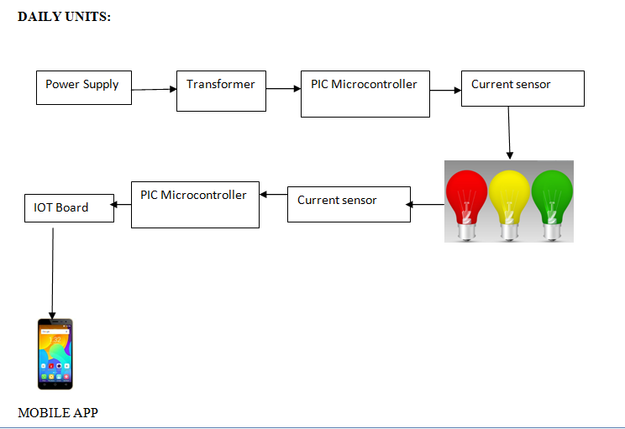

**Fig 3.3 Block diagram of daily unit consumption module**

**3.2.3 VOLTAGE FLUCTUATION**

Nowadays voltage fluctuation occurs frequently which is not intimated to the user. When the voltage goes low all the home appliances in order to work efficiently start to consume more power which results in a higher electricity bill but the user is not aware of this situation.

Hence the major module of the project is detecting the voltage level and when the voltage goes low the user is intimated so that they can switch off the devices which they do not require thus reducing the current consumed.

Whenever thevoltage level goes below 190Vintimation is sent to the user through the mobile application as well as a SMS is sent to the registered mobile number.

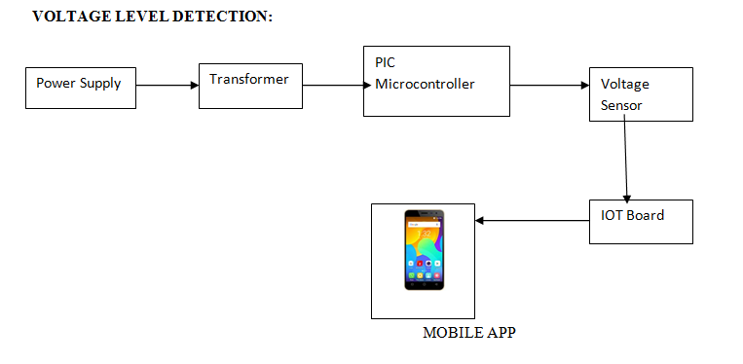**Fig 3.4 Block diagram for voltage level detection**

Whenever the user receives a low voltage message the user is requested to select 2 devices in the application, this data is then transmitted to the IoT board through the serial port which in turn is received by the PIC Microcontroller, it sends signals to the relay as to which device has to be switched off, thus the relay automatically switches off the selected device.

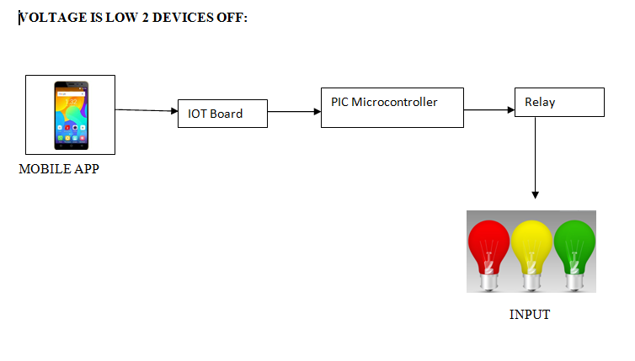

**Fig 3.5 Block diagram for voltage level detection**

**3.2.4 ONLINE PAYMENT**

Waiting in queues for payment is a tough task in this fast paced environment. Therefore we have implemented a secure payment portal by which once when the user receives a bill for his two month payment he can make the payment. The user is prompted to enter the banking details which are then validated over the network and if the authentication is right then it proceeds to the payment. The user can click on the PROCEED TO PAYMENT button to make the payment.



**Fig 3.6 Schematic diagram of payment module**

**3.3 UML DIAGRAMS:**

**3.3.1 Use Case Diagram:**

Use case diagrams are usually referreg to as behavior diagrams used to describe a set of actions (use cases) that some system or systems(subject) should or can perform in collaboration with one or more external users of the system(actors).Each use case should provide some observable and valuable result to the actors or other stakeholders of the system.



**Fig 3.7 Use case diagram**

**3.3.2 Class Diagram:**

A class diagram in the Unified ModelingLanguage (UML) is a type of static structure diagram that describes the structure of a system by showing the systems classes, their attributes, operations (or methods) and the relationships among objects.



**Fig 3.8 Class diagram**

**3.3.3 Sequence Diagram:**

A sequence diagram shows object interactions arranged in time sequence. It depicts the objects and classes involved in the scenario and the sequence of messages exchanged between the objects needed to carry out the functionality of the scenario. Sequence diagrams are typically associated with use case realizations in the Logical View of the system under development. Sequence diagrams are sometimes called event diagrams or event scenarios.



**Fig 3.9 Sequence diagram**

**4. REQUIREMENT SPECIFICATION**

**4.1 HARDWARE REQUIREMENTS:**

**4.1.1 PIC ASSEMBLED PCB+UART+LCD**

**GENERAL DESCRIPTION**

The microcontroller is a device that can perform a specific function according to the coding/program burnt into its program memory. The microcontrollers are special purpose devices used in many application like automobile, medical, instrumentation, battery management, smart phones accessories, motor and control drives, USB and wireless technology etc.

One of the most reputed manufacturers of micro-controller is MICROCHIP. PCB design. They have the vast series of micro-controllers from 8bit, 16, 32 bit controllers both in SMD and through whole package.

**PRODUCT DESCRIPTION**

This board is built with PIC16F877A as a microcontroller unit. The input supply to the board can be fed from both ac and dc. It uses a crystal oscillator for generating frequency. A serial communication is achieved by an UART protocol. This board is specially designed for connecting digital and analog sensors which has input voltage range 5 or 12VDC as well as it can be interfaced with serial communication devices, relay boards etc. The output can be monitored in LCD as well as pc. Data EEPROM is used to store data defined by the user. PCB design. When a variable is defined it is stored in program memory and the value of the variable is stored in data EEPROM Synchronous serial ports are used to communicate with other peripheral devices like serial EEPROMS, A/D converters and shift registers. PCB design. They have two modes. 1- SPI Serial Peripheral Interface 2- I2C Inter Integrated Circuit

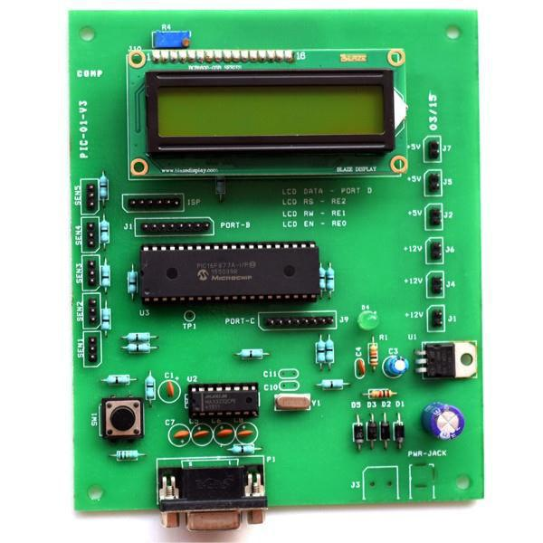

**Fig 4.1 PIC assembled PCB**

**FEATURES**

* Input Supply: Ac or Dc (9 to 12v)
* 8bit LCD
* RS232 output
* Analog channel: 5 sensor inputs
* Crystal frequency: 4mHz

**APPLICATIONS**

* Real time applications
* Academic applications

**4.1.2 SIMCOM GSM/GPRS MODEM**

**GENERAL DESCRIPTION**

SIMCom Wireless Solutions is a subsidiary of SIM Technology Group Ltd (stock code: 2000. H.K). It is a fast-growing wireless [M2M](https://en.wikipedia.org/wiki/Machine_to_machine) company, designing and offering a variety of wireless modules based on GSM/GPRS/EDGE, WCDMA/HSDPA and [TD-SCDMA](https://en.wikipedia.org/wiki/TD-SCDMA) technical platforms By partnering with third parties, SIMCom Wireless provides customized design [solutions](https://en.wikipedia.org/wiki/Solution) in M2M, WLL, Mobile Computing, GPS and other applications. SIMCom Wireless also provides [ODM](https://en.wikipedia.org/wiki/Original_design_manufacturer) services for customers. According to ABI Insight report, SIMCom Cellular Module was number two provider of wireless modules worldwide in 2008 with 20% acquisition of global market share

**PRODUCT DESCRIPTION**

This GSM Modem can accept any GSM network act as SIM card and just like a mobile phone with its own unique phone number. Advantage of using this modem will be that you can use its RS232 port to communicate and develop embedded applications. The SIM900A is a complete Dual-band GSM/GPRS solution in a SMT module featuring an industry-standard interface; the SIM800 delivers GSM/GPRS 900/1800MHz performance for voice, SMS, Data, and Fax in a small form factor and with low power consumption. With a tiny configuration of 24mm x 24mm x 3 mm, SIM800 can fit almost all the space requirements in your applications, especially for slim and compact demand of design.

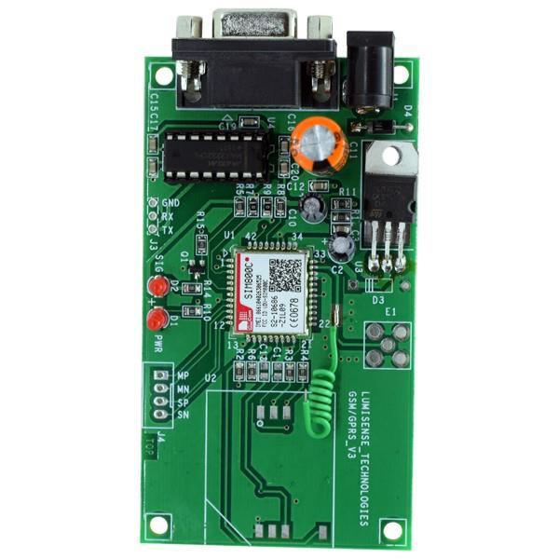

**Fig 4.2 GSM MODEM**

**FEATURES**

* High Quality Product
* RS232 interface @ RMC Connector for direct communication with computer or MCU kit
* Configurable baud rate
* SMA connector with GSM Antenna.
* SIM Card holder.
* Built in Network Status LED
* Inbuilt Powerful TCP/IP protocol stack for internet data transfer over GPRS.
* Audio interface Connector
* Normal operation temperature: -20 °C to +55 °C
* Input Voltage: 4.5V-12V DC

**APPLICATIONS**

* Short Message Service(SMS)
* Internet
* Incoming /outgoing calls

**4.1.3 AC CURRENT SENSOR**

**GENERAL DESCRIPTION**

A current sensor (CT1270) is a device that detects [electric current](https://en.wikipedia.org/wiki/Electric_current) (AC or DC) in a wire, and generates a signal proportional to it. The generated signal could be analog voltage or current or even digital output.

**PRODUCT DESCRIPTION**

When a current flows through a wire or in a circuit, voltage drop occurs. Also, a magnetic field is generated surrounding the current carrying conductor. Both of these phenomena are made use of in the design of current sensors. Thus, there are two types of current sensing: direct and indirect. Direct sensing is based on Ohm’s law, while indirect sensing is based on Faraday’s and Ampere’s law. Direct Sensing involves measuring the voltage drop associated with the current passing through passive electrical components.

Indirect Sensing involves measurement of the magnetic field surrounding a conductor through which current passes. Generated magnetic field is then used to induce proportional voltage or current which is then transformed to a form suitable for measurement and/or control system.

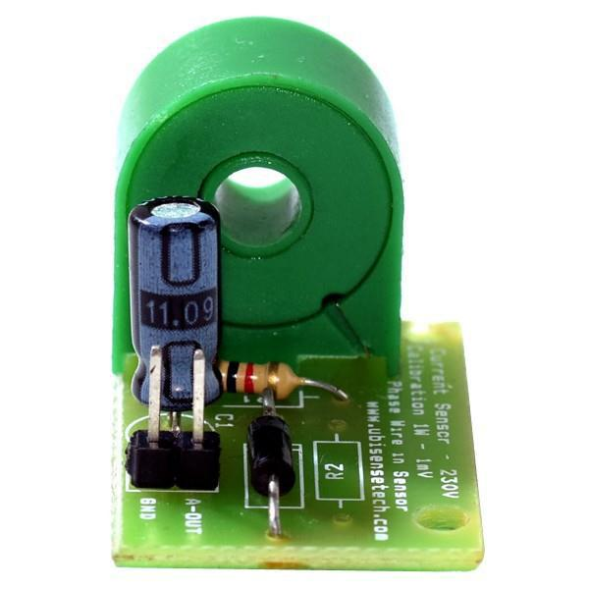

**Fig 4.3 AC current sensor**

**FEATURES**

* Supply voltage: 5v DC
* Output: analog
* Small size
* Low cost

**APPLICATIONS**

* Ammeters
* Current control purposes
* DC/DC converters
* Ground fault detectors

**4.1.4 AC VOLTAGE SENSOR**

**GENERAL DESCRIPTION**

The Voltage Sensor block represents an ideal voltage sensor, that is, a device that converts voltage measured between two points of an electrical circuit into a physical signal proportional to the voltage. Connections + and – are electrical conserving ports through which the sensor is connected to the circuit. Connection V is a physical signal port that outputs the measurement result.

**PRODUCT DESCRIPTION**

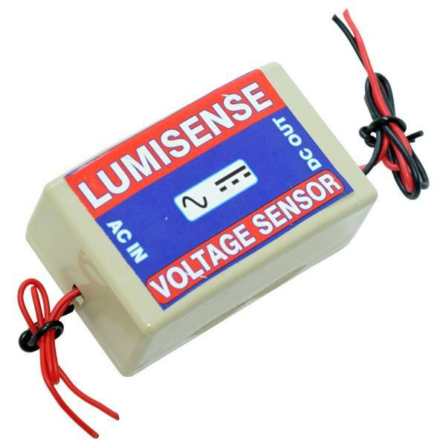AC voltage sensor works according to Magnetic Modulation and is designed for AC voltage measurement. The output signal of this sensor is proportional to the input AC voltage. It can be used for continuous ac voltage monitoring of the system.

**Fig 4.4 AC voltage sensor**

**FEATURES**

* Under-voltage, over-voltage, or voltage band models
* Powered from sensing input lines or from separate AC supply
* Available with time delays on pull-in and/or drop-out or with customized voltage-time trip curves

**APPLICATIONS**

* Power generation unit
* Power transmission unit
* Industry and other applications

**4.1.5 ADAPTER**

**GENERAL DESCRIPTION**

An adapter is a device that converts attributes of one electrical device or system to those of an otherwise incompatible device or system. Some modify power or signal attributes, while others merely adapt the physical form of one [electrical connector](https://en.wikipedia.org/wiki/Electrical_connector) to another.

In a computer, an adapter is often built into a card that can be inserted into a slot on the computer's motherboard. The card adapts information that is exchanged between the computer's microprocessor and the devices that the card supports.

**PRODUCT DESCRIPTION**

An electric power adapter may enable connection of a power plug, sometimes called, used in one region to a AC power socket used in another, by offering connections for the disparate contact arrangements, while not changing the voltage. An AC adapter, also called a "recharger", is a small power supply that changes household electric current from distribution voltage) to low voltage DC suitable for consumer electronics**.**

Some modify power or signal attributes, while others merely adapt the physical form of one electrical connector to another. For computers and related items, one kind of serial port adapter enables connections between 25-contact and

nine-contact connectors, but does not affect electrical power- and signalling-related attributes.

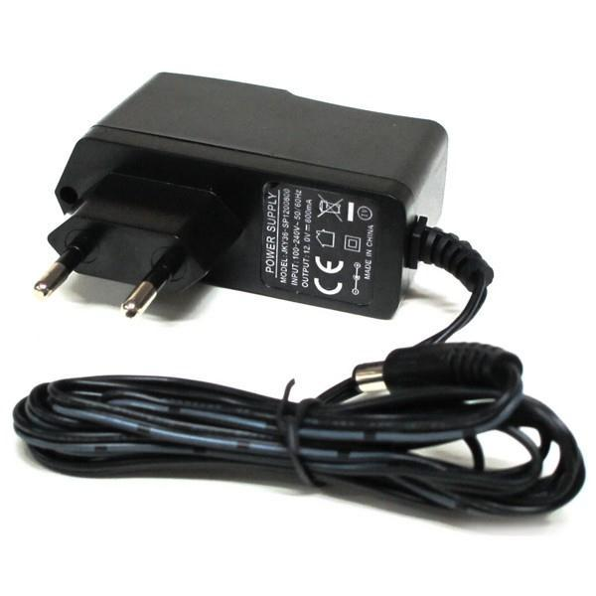

**Fig 4.5 Adapter**

**FEATURES**

* Output current:1A
* Supply voltage: 220-230VAC
* Output voltage: 12VDC
* Reduced costs
* Increased value across front-office and back-office functions
* Access to current, accurate, and consistent data
* It generates adapter metadata as WSDL files with J2CA extension.

**APPLICATIONS**

* Back-end systems which need to send purchase order data to oracle applications send it to the integration service via a integration server client.
* SMPS applications.
* The PO is then inserted into the oracle applications system and the processed result is sent back to the integration server.
* An adapter can be used by a single application or it can be used by more than one application.
* RPS applications.
* It is used for hosted Web applications.

**4.1.6 FOUR RELAY BOARD**

**GENERAL DESCRIPTION**

Relays are simple switches which are operated both electrically and mechanically. Relays consist of a n electromagnet and also a set of contacts. The switching mechanism is carried out with the help of the electromagnet. The main operation of a relay comes in places where only a low-power signal can be used to control a circuit. It is also used in places where only one signal can be used to control a lot of circuits.

They were used to switch the signal coming from one source to another destination. The high end applications of relays require high power to be driven by electric motors and so on. Such relays are called contactors.

**PRODUCT DESCRIPTION**

A relay is an electromechanical switch which is activated by an electric current. A four relay board arrangement contains driver circuit, power supply circuit and isolation circuit. A relay is assembled with that circuit. The driver circuit contains transistors for switching operations. The transistor is use for switching the relay.

An isolation circuit prevents reverse voltage from the relay which protects the controller and transistor from damage. The input pulse for switching the transistor is given from the microcontroller unit. It is used for switching of a four device.

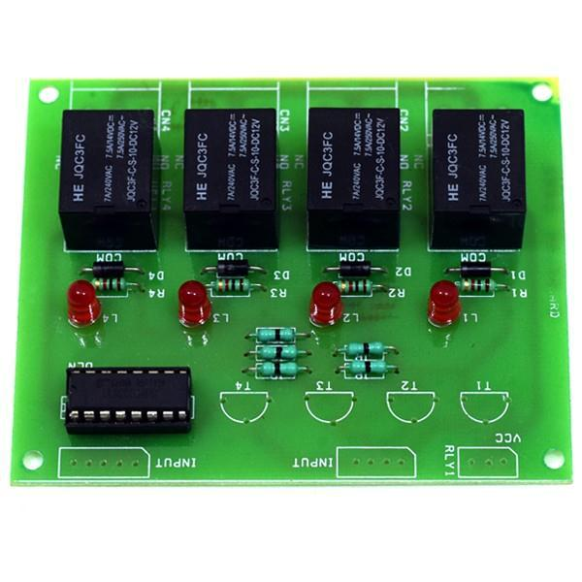

**Fig 4.6 Four Relay Board**

**FEATURES**

* Input voltage: 12VDC
* Driver unit: ULN2003A
* Isolation unit: In4007
* Fast switching
* Motor forward and reverse operation

**APPLICATIONS**

* Ac load Switching applications
* Dc load Switching applications
* Motor switching applications

**4.1.7 TRANSFORMER (0-12V/1A)**

**GENERAL DESCRIPTION**

It is a general purpose chassis mounting mains transformer. Transformer has 240V primary windings and centre tapped secondary winding. The transformer has flying colored insulated connecting leads (Approx 100 mm long). The Transformer act as step down transformer reducing AC - 240V to AC - 12V. Power supplies for all kinds of project & circuit boards.

Step down 230 V AC to 12V with a maximum of 1Amp current. In AC circuits, AC voltage, current and waveform can be transformed with the help of Transformers. Transformer plays an important role in electronic equipment. AC and DC voltage in Power supply equipment are almost achieved by transformer’s transformation and commutation

**PRODUCT DESCRIPTION**

A transformer is an electrical device that transfers electrical energy between two or more circuits through electromagnetic induction. Electromagnetic induction produces an electromotive force within a conductor which is exposed to time varying magnetic fields. Transformers are used to increase or decrease the alternating voltages in electric power applications.

It is a step down transformer in which the secondary winding is more than primary winding. Due to this windings it can able to step down the voltage. A Transformer changes electricity from high to low voltage or low to high voltage using two properties of electricity.

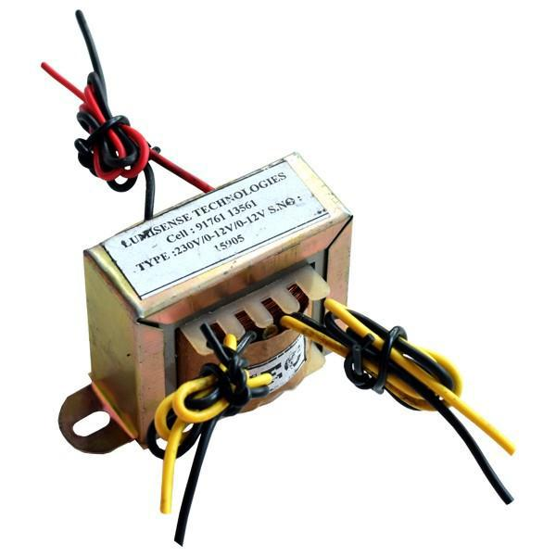

**Fig 4.7 Transformer**

**FEATURES**

* Output current:1A
* Supply voltage: 220-230VAC
* Output voltage: 12VAC
* Soft Iron Core
* 1Amp Current Drain

**APPLICATIONS**

* DIY projects Requiring In-Application High current drain.
* On chassis AC/AC converter.
* Designing a battery Charger.
* Electronic applications.
* Step down applications (Power transmission).

**4.1.8 PIC16F877A**

**GENERAL DESCRIPTION**

The 16F877A is a capable microcontroller that can do many tasks because it has a large enough programming memory (large in terms of sensor and control projects) 8k words and 368 Bytes of RAM. This is enough to do many different projects.

The 40 pins make it easier to use the peripherals as the functions are spread out over the pins. This makes it easier to decide what external devices to attach without worrying too much if there are enough pins to do the job. One of the main advantages is that each pin is only shared between two or three functions so its easier to decide what the pin function.

**PRODUCT DESCRIPTION**

This powerful (200 nanosecond instruction execution) yet easy-to-program (only 35 single word instructions) CMOS FLASH-based 8-bit microcontroller packs Microchip's powerful PIC® architecture into an 40- or 44-pin package and is upwards compatible with the PIC16C5X, PIC12CXXX and PIC16C7X devices.

The PIC16F877A features 256 bytes of EEPROM data memory, self programming, an ICD, 2 Comparators, 8 channels of 10-bit Analog-to-Digital (A/D) converter, 2 capture/compare/PWM functions, the synchronous serial port. Transmitter (USART). All of these features make it ideal for more advanced level A/D applications in automotive, industrial, appliances and consumer applications.

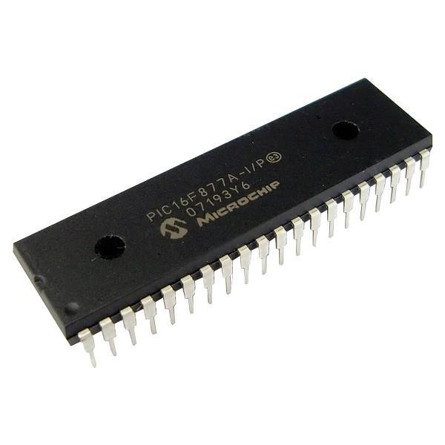

**Fig 4.8 PIC16F877**

**FEATURES**

* External gate.
* Volt Reference.
* Nano Watt.
* Internal Clock.
* 2 PWM 10-bit

**APPLICATIONS**

* House hold appliances
* Office equipment
* Instruments

**4.2 SOFTWARE REQUIRMENTS**

**4.2.1 WINDOWS 7**

**FEATURES:**

The WFU standard operating system for the ThinkPad is the Microsoft 32 bit Windows 7 Enterprise edition.  The primary features of Windows 7 are:

[**Start Menu**](http://college.wfu.edu/itg/help/thinkpad-training-resources/start-menu-items) – The Start Menu provides the primary access point for programs and applications on your ThinkPad.

[**Taskbar and Notification Area**](http://college.wfu.edu/itg/help/thinkpad-training-resources/windows-7-taskbar)– The Taskbar contains 3 main components, the Start button, the Task/Quick launch bar and the System Notification Area.

[**Windows Snipping Tool**](http://college.wfu.edu/itg/help/thinkpad-training-resources/windows-7-snipit-application) – Windows 7 includes an application to capture, save and share “snipped” images from your desktop.

[**Displaying to an External Monitor or Projector**](http://college.wfu.edu/itg/help/thinkpad-training-resources/displaying-to-a-external-monitor-or-projector) – The ThinkPad is equipped with one or more external display connectors so that you may connect to an external monitor or the multimedia projector.

[**Using Local Area Networks (LAN/Wi-Fi)**](http://college.wfu.edu/itg/help/thinkpad-training-resources/using-local-area-networks-lan)– The ThinkPad is configured to access both wired and wireless network resources.

[**Windows Explorer Favorites**](http://college.wfu.edu/itg/help/thinkpad-training-resources/windows-7-file-system-favorites)– File system favorites are quick links to specific directories (folders) located on your hard drive.

[**Windows Explorer Libraries**](http://college.wfu.edu/itg/help/thinkpad-training-resources/windows-7-file-system-libraries) – Libraries are an easy way to collect and track documents on your computer that are related to one another but are not necessarily located in the same directories (folders).

**4.2.2 EMBEDDED C**

**EMBEDDED SYSTEMS PROGRAMMING**

Embedded systems programming is different from developing applications on a desktop computers. Key characteristics of an embedded system, when compared to PCs, are as follows:

* Embedded devices have resource constraints(limited ROM, limited RAM, limited stack space, less processing power)
* Components used in embedded system and PCs are different; embedded systems typically uses smaller, less power consuming components.
* Embedded systems are more tied to the hardware.

Two salient **features of Embedded Programming** are code speed and code size. Code speed is governed by the processing power, timing constraints, whereas code size is governed by available program memory and use of programming language.  Goal of embedded system programming is to get maximum features in minimum space and minimum time.

Embedded systems are programmed using different type of languages:

* Machine Code
* Low level language, i.e., assembly
* High level language like C, C++, Java, Ada, etc.
* Application level language like Visual Basic, scripts, Access, etc.

**4.2.3 ANDROID STUDIO**

Android studio is based on IntelliJ IDEA, which does all the functionality that Eclipse with ADT plug-in do, with lot more additional features. The initial version of android studio offers

1. Gradle-based build support.
2. Android-specific refactoring and quick fixes
3. Lint tools to catch performance, usability, version compatibility and other problems
4. ProGuard and app-signing capabilities
5. Template-based wizards to create common Android designs and components.
6. **A rich layout editor:** it allows you to drag-and-drop UI components, preview layouts on multiple screen configurations. Preview appears instantly as you change in the layout editor. You can choose a language, and can see the preview of layout with that locale.
7. **Rich Color Preview editor:** While adding colors as a resource, and we can see the color preview at the left hand side of the editor.
8. **Deep Code Analysis:** If you point to a line and it gives detailed explanation about an exception based on the annotation added. And you can also know which constants are allowed for which API. It also has the powerful code completion. You can also inspect code in whole project,InteliJ lists all Lint errors during code inspection.

**5. IMPLEMENTATION:**

**5.1 SAMPLE CODE:**

**LoginActivity.java:**

packagecom.example.smartmeter;

import android.*;

public class LoginActivity extends Activity {

btnSave.setOnClickListener(new OnClickListener() {

@Override

public void onClick(View arg0) {

Save();}});

btnRetr=(Button) findViewById(R.id.btnRetr);

btnRetr.setOnClickListener(new OnClickListener() {

@Override

public void onClick(View arg0) {

Get();}});}

public void Save() {

String n = name.getText().toString();

String e = email.getText().toString();

SharedPreferences.Editor editor = sharedpreferences.edit();

editor.putString(Name, n);

editor.putString(Email, e);

public void clear(View view) {

name = (EditText) findViewById(R.id.etName);

email = (EditText) findViewById(R.id.etEmail);

name.setText("");

email.setText("");

}

public void Get() {

name = (EditText) findViewById(R.id.etName);

email = (EditText) findViewById(R.id.etEmail);

sharedpreferences = getSharedPreferences(mypreference,

Context.MODE_PRIVATE);

String n = name.getText().toString();

String e = email.getText().toString();

String ns=sharedpreferences.getString(Name, "");

String es=sharedpreferences.getString(Email, "");

if(n.compares(ns) &&e.compares(es))

{Toast.makeText(getApplicationContext(), "Login Success",Toast.LENGTH_SHORT).show();

Intent in=new Intent(LoginActivity.this, MainActivity.class);

startActivity(in); }

else

{Toast.makeText(getApplicationContext(), "Login Failed", Toast.LENGTH_SHORT).show();

}}

@Override

publicbooleanonCreateOptionsMenu(Menu menu) {

getMenuInflater().inflate(R.menu.main, menu);

return true;

}}

**MainActivity.java:**

packagecom.example.smartmeter;

import android.support.v7.app.ActionBarActivity;

import android.*;

public class MainActivity extends ActionBarActivity {

new Thread(new Runnable() {

@Override

public void run() {

for(int i = 0; i < 100; i++) {

runOnUiThread(new Runnable() {

@Override

});

try {

Thread.sleep(20000);

}}}}).start();}

private voidreceivedata() {

Intent serverIntent = new Intent(MainActivity.this, HttpConnectSample.class);

Bundle b= new Bundle();

b.putString("cstatus", cstatus);

serverIntent.putExtras(b);

startActivityForResult(serverIntent, REQUEST_CONNECT_DEVICE);}

@Override

publicbooleanonCreateOptionsMenu(Menu menu) {

getMenuInflater().inflate(R.menu.main, menu);

return true;}

public void showCustomAlert()

{Context context =tact.getBaseContext();

LayoutInflaterinflater = (LayoutInflater)getSystemService(Context.LAYOUT_INFLATER_SERVICE);

View toastRoot = inflater.inflate(R.layout.toast_layout, null);

ImageViewimagev = (ImageView) toastRoot.findViewById(R.id.image);

TextViewtextv = (TextView) toastRoot.findViewById(R.id.text);

imagev.setImageResource(R.drawable.reddot);

textv.setText(alertmsg);

Toast toast = new Toast(context);

toast.setView(toastRoot);

toast.setGravity(Gravity.CENTER_HORIZONTAL | Gravity.CENTER_VERTICAL,0, 0);

toast.setDuration(Toast.LENGTH_LONG);

toast.show();}

public void onActivityResult(intrequestCode,intresultCode, Intent data) { String address = data.getExtras().getString(HttpConnectSample.CARD_DATA);

if(address != null && !address.isEmpty())

{ String[] datas = address.split(",");

et.setText(datas[0]);

et1.setText(datas[0]);

et2.setText(datas[1]);

et3.setText(datas[2]);

et4.setText(datas[3]);

et5.setText(datas[4]);

et6.setText(datas[5]);

et7.setText(datas[6]);

et8.setText(datas[7]);

monusage=Integer.parseInt(datas[7]);

int e1=Integer.parseInt(datas[8]);

if(e1<190)

{et9.setText("Voltage : Low");}}}

public void addListenerOnButton() {

btn1 = (Button) findViewById(R.id.b12);

btn1.setOnClickListener(new OnClickListener() {

@Override

public void onClick(View arg0) {

int bill=0;

bill=monusage*7;

Intent intent=new Intent(MainActivity.this, PaymentActivity.class);

Bundle b=new Bundle();

b.putString("bill", String.valueOf(bill));

intent.putExtras(b);}}); }@Override

publicbooleanonOptionsItemSelected(MenuItem item) {

int id = item.getItemId();

if (id == R.id.action_settings) {

return true;}

returnsuper.onOptionsItemSelected(item);

}}

**PaymentActivity.java:**

packagecom.example.smartmeter;

import android.*;

public class PaymentActivity extends Activity {

public String alertmsg=null;

Button b12;

MainActivity tact;

EditText entry; @Override

protected void onCreate(Bundle savedInstanceState) {

super.onCreate(savedInstanceState);

setContentView(R.layout.payment);

entry=(EditText) findViewById(R.id.entry);

Bundle b=getIntent().getExtras();

String a=(String) b.getCharSequence("bill");

entry.setText(a);

Log.d("amount", a);

b12 = (Button) findViewById(R.id.b12);}

public void showCustomAlert()

{ Contextcontext =tact.getBaseContext();

LayoutInflaterinflater = (LayoutInflater)getSystemService(Context.LAYOUT_INFLATER_SERVICE);

View toastRoot = inflater.inflate(R.layout.toast_layout, null);

ImageViewimagev = (ImageView) toastRoot.findViewById(R.id.image);

TextViewtextv = (TextView) toastRoot.findViewById(R.id.text);

imagev.setImageResource(R.drawable.reddot);

textv.setText(alertmsg);

Toast toast = new Toast(context);

toast.setView(toastRoot);

toast.setGravity(Gravity.CENTER_HORIZONTALGravity.CENTER_VERTICAL,0, 0);

toast.setDuration(Toast.LENGTH_LONG);

toast.show();}

public void addListenerOnButton() {

b12 = (Button) findViewById(R.id.b12);

b12.setOnClickListener(new OnClickListener() { @Override

public void onClick(View arg0) {

alertmsg="Payment Success";

showCustomAlert();

}});}

public void payment(View view) {

Toast.makeText(getApplicationContext(), "Payment Success", Toast.LENGTH_SHORT).show();

}@Override

publicbooleanonCreateOptionsMenu(Menu menu) {

getMenuInflater().inflate(R.menu.main, menu);

return true;}}

**HttpConnectSample.java:**

packagecom.example.smartmeter;

import java.*;

import android.*;

public class HttpConnectSample extends Activity {

protected static final String Length = null;

private Button getTextButton;

privateProgressDialogprogressDialog;

private Bitmap bitmap = null;

private String text;

MainActivity tact;

@Override public void onCreate(Bundle savedInstanceState) {

super.onCreate(savedInstanceState);

setContentView(R.layout.httpconnect);

new Thread(new Runnable() { @Override

public void run() {

runOnUiThread(new Runnable() {@Override

public void run() {

Log.d("url","http://IoTclouddata.com/project/getmeter.php");

downloadText("http://IoTclouddata.com/project/getmeter.php");

}});

}}).start();}

private void downloadText(String urlStr) {

progressDialog = ProgressDialog.show(this, "", "Connecting Server...");

final String url =urlStr;

new Thread () {

public void run() {

int BUFFER_SIZE = 2000;

InputStream in = null;

Message msg = Message.obtain();

msg.what=2;

try {

in=openHttpConnection(url);

InputStreamReaderisr = new InputStreamReader(in);

intcharRead;

text = "";

char[] inputBuffer = new char[BUFFER_SIZE];

Bundle b = new Bundle();

b.putString("text", text);

msg.setData(b);

in.close();

}catch (Exception e) {

e.printStackTrace(); }

messageHandler.sendMessage(msg);}

}.start();}

privateInputStreamopenHttpConnection(String urlStr) {

InputStream in = null;

intresCode = -1;

try {

URL url = new URL(urlStr);

URLConnectionurlConn = url.openConnection();

if (!(urlConninstanceofHttpURLConnection)) {

throw new IOException ("URL is not an Http URL");

}

HttpURLConnectionhttpConn = (HttpURLConnection)urlConn;

httpConn.setAllowUserInteraction(false);

httpConn.setInstanceFollowRedirects(true);

httpConn.setRequestMethod("GET");

httpConn.connect();

resCode = httpConn.getResponseCode();

System.out.print(resCode);

if (resCode == HttpURLConnection.HTTP_OK) {

in = httpConn.getInputStream();

} } catch (MalformedURLException e) {

e.printStackTrace();

} catch (IOException e) {

e.printStackTrace();}

return in;}

private Handler messageHandler = new Handler() {

public void handleMessage(Message msg) {

super.handleMessage(msg);

switch (msg.what) {

case 1:

break;

case 2:

try{

Intent intent = new Intent(); intent.putExtra(CARD_DATA,msg.getData().getString("text"));

setResult(Activity.RESULT_OK, intent);

finish();

}catch(NullPointerException e)

{}

break;}

progressDialog.dismiss();

}};}

**EMBEDDED C CODE:**

#include <htc.h>

#include "lcd16.h"

voidtxs(unsigned char val)

{int i;

while(!TXIF)

continue;

TXREG=val;

for(i=0;i<4000;i++);}

void delay2()

{long i;

for(i=0;i<200000;i++);}

unsigned char rxs(void)

{while(!RCIF)

continue;

return RCREG;}

void delay10s()

{delay2();}

voidsendtx(unsigned char val[],unsigned char length)

{ int i;

for(i=0;i<length;i++)

{txs(val[i]);}}

unsigned char val1[8],val[10],rval,f1,f2,f3;

void init_a2d(void){

ADCON0=0; // select Fosc/2

ADCON1=2; // select left justify result. A/D port configuration 0

ADON=1; // turn on the A2D conversion module

}unsigned char read_a2d(unsigned char channel){

channel&=0x07; // truncate channel to 3 bits

ADCON0&=0xC5; // clear current channel select

ADCON0|=(channel<<3); // apply the new channel select

GO=1; // initiate conversion on the selected channel

while(GO)continue;

return(ADRESH); // return 8 MSB of the result

} unsignedinthb=0,hbt=0,hbtt=0,d,i,unit,unit1,yunit,sm=0;

voidsms(){

txs('A');txs('T');txs('+');txs('C');txs('M');txs('G');

txs('S');txs('=');

txs('"');txs('9');txs('4');txs('4');txs('4'); txs('4');txs('4');txs('1');txs('7');txs('7');txs('4');txs('"');txs(13); txs(10);

delay2();

txs('L');txs('o');txs('w');txs(' ');txs(' ');txs('V');txs('o');txs('l');txs('t');txs('a');txs('g');

txs('g');txs('e');txs(' ');txs(':');

txs(((val[0])/100)+0x30);

txs(((val[0])/10)+0x30);

txs((val[0])+0x30);

txs(13); txs(10); delay(10000);

txs(26);}

void main() //Main entry

{ TRISD=0x00;

TRISE=0x00;

RCSTA=0x90;// receive enabling with the same speed

TXSTA =(0x24); // High speed selection baud rate 9600

SPBRG = 64;

Lcdinit();

init_a2d();

TRISC=0xa1;

TRISB=0xf0;

nRBPU=0;

RB0=1;

RB1=1;

RB2=1;

TRISC0=0;

TRISC1=0;

TRISC2=0;

TRISC3=0;

RC0=1;

RC1=1;

RC2=1;

Lcdcmd(0xC0);

lcddata('W');

lcddata('a');

lcddata('i');

lcddata('t');

lcddata('.');

lcddata('.');

txs('A');txs('T');txs('+');txs('C');txs('M');txs('G');

txs('F');txs('=');txs('1');txs(13); txs(10);

delay2();

sendtx("at+cgact=1,1",13);

txs(13);txs(10);

delay10s();

sendtx("at+cgreg=2",11);

txs(13);txs(10);

delay10s();

sendtx("AT+CIICR",8);

txs(13);txs(10);

delay10s();

sendtx("AT+CIFSR",8);

txs(13);txs(10);

delay10s();

sendtx("AT+CIPHEAD=1",12);

txs(13);txs(10);

delay10s();

Lcdcmd(0xC0);

lcddata(' ');

lcddata(' ');

lcddata(' ');

lcddata(' ');

lcddata(' ');

lcddata(' ');

while(1)

{

while(RCIF==0)

{ ll++;

Lcdcmd(0xC0);

lcddata('M');

lcddata('e');

lcddata('t');

lcddata('e');

lcddata('r');

lcddata('=');

lcddata((unit/100)+0x30);

lcddata((unit%100)/10+0x30);

lcddata((unit%10)+0x30);

val[0]=read_a2d(0)+100;

Lcdcmd(0x80);

lcddata('V');

lcddata((val[0]/100)+0x30);

lcddata((val[0]%100)/10+0x30);

lcddata((val[0]%10)+0x30);

val[1]=read_a2d(1);

Lcdcmd(0x85);

lcddata('I');

lcddata((val[1]/100)+0x30);

lcddata((val[1]%100)/10+0x30);

lcddata((val[1]%10)+0x30);

val[2]=read_a2d(2);

Lcdcmd(0x85);

lcddata('I');

lcddata((val[2]/100)+0x30);

lcddata((val[2]%100)/10+0x30);

lcddata((val[2]%10)+0x30);

val[3]=read_a2d(3);

Lcdcmd(0x85);

lcddata('I');

lcddata((val[3]/100)+0x30);

lcddata((val[3]%100)/10+0x30);

lcddata((val[3]%10)+0x30);

d=val[0]*(val[1]+val[2]+val[3]);

Lcdcmd(0x8A);

lcddata('P');

lcddata((d/10000)+0x30);

lcddata((d%10000)/1000+0x30);

lcddata((d%1000)/100+0x30);

lcddata((d%100)/10+0x30);

lcddata((d%10)+0x30);

if(d>10000)

{

if(ll<50)

unit=unit+1;

if((ll>50)&& (ll<100))

unit1=unit1+1;

for(i=0;i<40000;i++);

for(i=0;i<40000;i++);

}

if(val[0]<190)

{if(f3==0){sms2();f3=1;}}

if(val[0]<210)

{RC0=1;

RC1=1;

RC2=0;}

if(val[0]<190)

{RC0=1;

RC1=0;

RC2=0;}

if(val[0]<150)

{RC0=0;

RC1=0;

RC2=0;}

if(val[0]>225)

{RC0=1;

RC1=1;

RC2=1;}}

rval=RCREG;

RCIF=0;

OERR=0;

CREN=0;

CREN=1;

Lcdcmd(0xcf);

lcddata(rval);}}

**5.2 SAMPLE SCREENSHOTS**

**REGISTRATION PAGE**

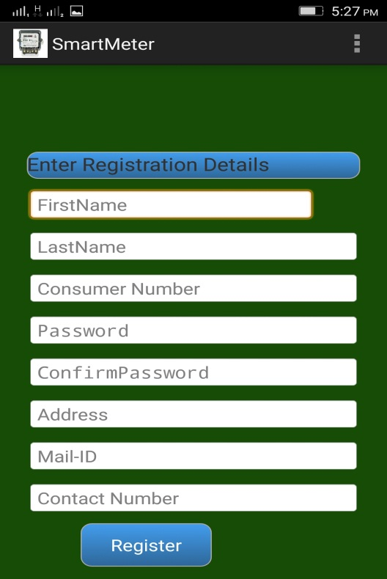

**User has to enter the registration details**

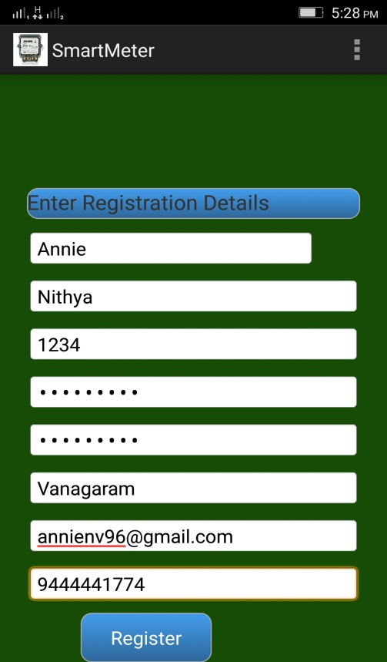

**Fig 5.1 Registration page**

**LOGIN PAGE**

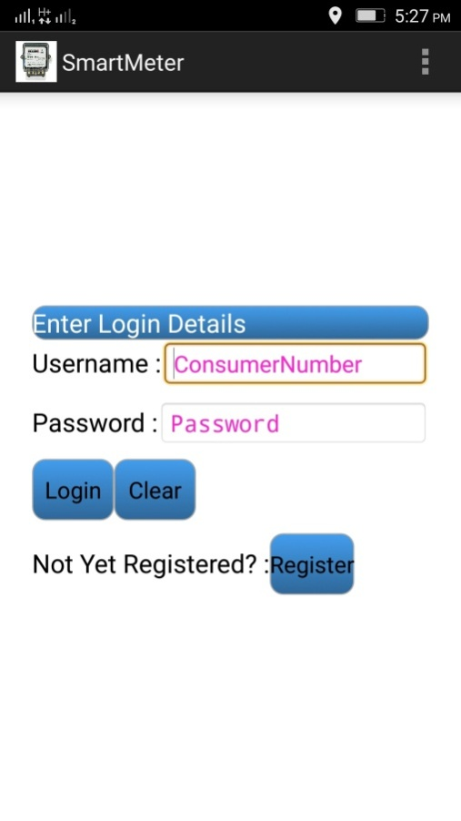

**User can login using the details which has been registered**

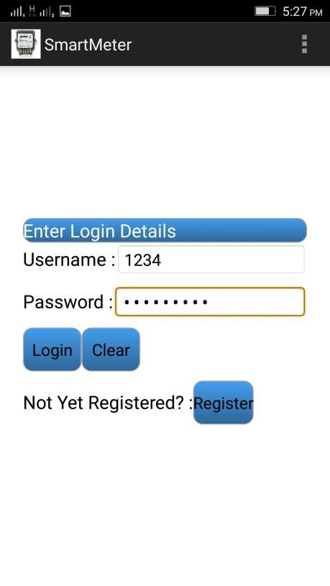

**DAILY READINGS**

**User can view the units consumed each day, the past 7 days and the , months total usage**

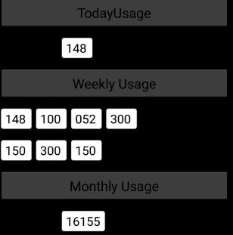

**VOLTAGE IS NOMAL**

**When there is normal all the input devices are switched on**

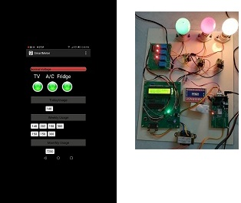

**VOLTAGE IS LOW**

**When voltage is low 2 devices are automatically switched off which are selected by the user**

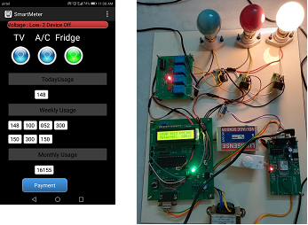

**LOW VOLTAGE INTIMATION VIA SMS**

**The user receives an SMS when the voltage is low**

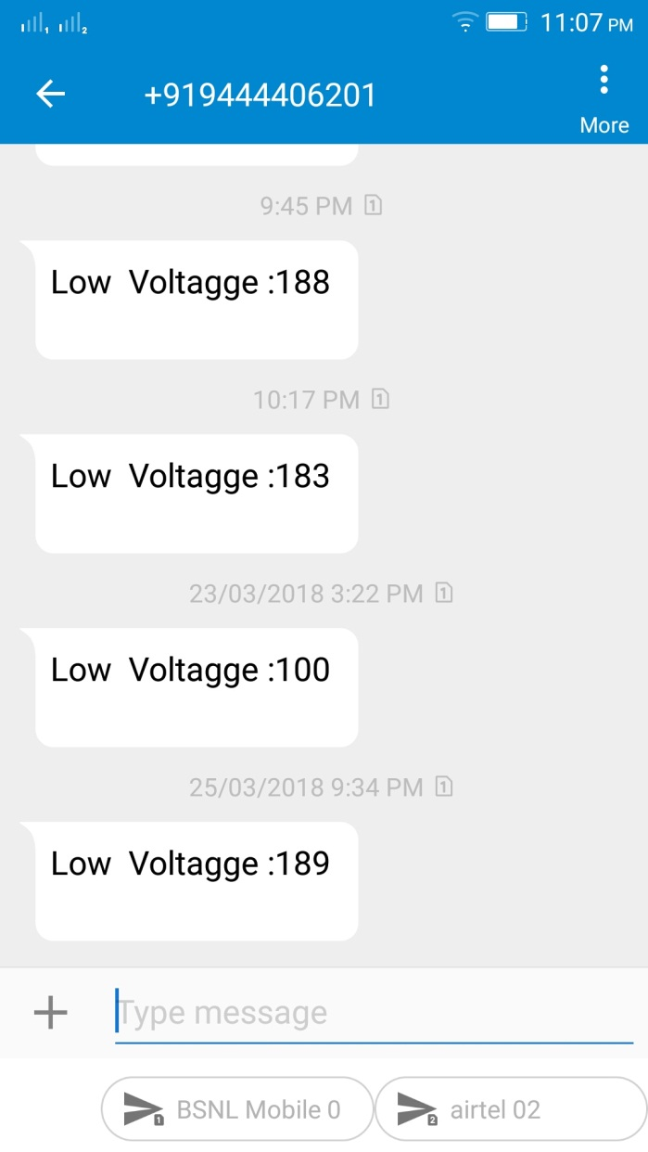

**PAYMENT PAGE:**

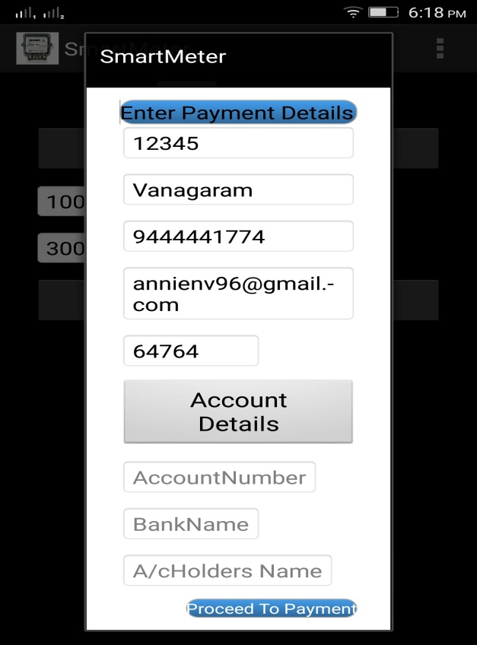

**User can make payment by entering the bank details**

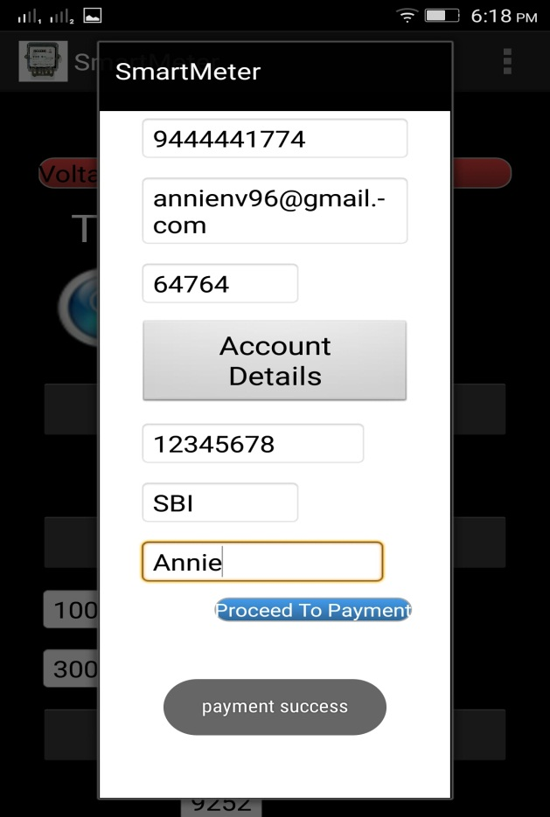

**CONCLUSION AND FUTURE ENHANCEMENT:**

The project deals with the designing of the sensing circuits for Smart Meter(SM) system. The main objective is to measure the electricity consumed daily and monthly and use them in an efficient manner without wasting the energy by monitoring the electricity power consumption which creates awareness among the user. By using this Smart Meter(SM) system the low voltage level is intimated to the user which prevents the device from consuming more power.

In future high voltage can be distributed and managed. If the user has any queries it can be intimated to the electricity board via mail through the application. Each months average usage level can be intimated to the user through alert message.

**REFERENCES:**

1. Ashraf Khalil, ZakariyaRajab(2017), ‘Load Frequency Control system

with Smart Meter and Controllable Loads’,The 8th International

Renewable Energy Congress

2. BabakKarimi, VinodNamboodiri, and MurtuzaJadliwala(2015),

‘Scalable Meter Data Collection in Smart Grids Through Message

Concatenation’, IEEE Transactions On Smart Grid, Vol. 6, No. 4, July

3. DammindaAlahakoonand XinghuoYu,Fellow(2016), ‘Smart Electricity

Meter Data Intelligence for Future Energy Systems: A Survey’,IEEE Transaction on Industrial Informatics, Vol.12,NO. 1.

4. GiulioGiaconi, DenizGund and H. Vincent Poor, (2017), ‘Smart Meter

Privacy with Renewable Energy and an Energy Storage Device’ , IEEE

5. Jayant.P.Pawar, Amirthaganesh.S, ArunKumar.S, SatieshKumar.B,

(2016) ‘REAL TIME ENERGY MEASUREMENT USINGSMART METER’,Online Conference on Green Engineering and Technologies (IC-GET)

6. NegreaLiviuAndrei,VladimirTanasiev, MihaiSanduleac,( 2014),

‘Smart metering platform as a solution for data analysis’,PNII carried out by MEN-UEFISCDI

7. SavitaPawar,Dr. B. F. Momin, (2016), ‘Smart Electricity Meter Data

Analytics: A Brief Review’, IEEE

8. Wen-Shyong Yu and Yi-Jie Fang,( 2017), ‘ Data Analysis of the Smart

Meters and Its Applications in Tatung University’, IEEE

9. Xing Tong, Chongqing Kang, and Qing Xia ,(2015), ‘Smart Metering

Load Data Compression Based on Load Feature Identification’, IEEE Transactions On Smart Grid, Vol. 6, No. 4.

10. Yasin and Ersan, (2016) ,‘A Low Cost Smart Metering System Design

for Smart Grid Applications’,International Conference – 8th Edition